SalesKik - Tradies and Sole Traders Module (Conversational Breakdown with Visuals)

Overview
The 'Tradies and Sole Traders' section of SalesKik is designed for one-person businesses or small trade operators who need an easy-to-use system to manage quotes, jobs, customers, and payments without the complexity of bigger business tools. This module keeps everything streamlined so they can focus on their trade while SalesKik takes care of the admin. It’s built for people who are often on the move, on-site, and need fast, reliable tools from their phone or tablet.

Module 1: Quick Quote Builder
Here’s what 'Module 1: Quick Quote Builder' means for a tradie or sole trader using SalesKik:
- Generate professional quotes in under two minutes using preloaded templates.
- Attach product images, specifications, and pricing with just a few taps.
- Send quotes via SMS, email, or shareable link instantly from a phone or tablet.
When you’re in front of a customer, speed matters. This tool lets you build a quote on your phone in just a couple of taps, pulling in items from your catalogue and pricing automatically. You can send it on the spot to lock in the job before you leave.
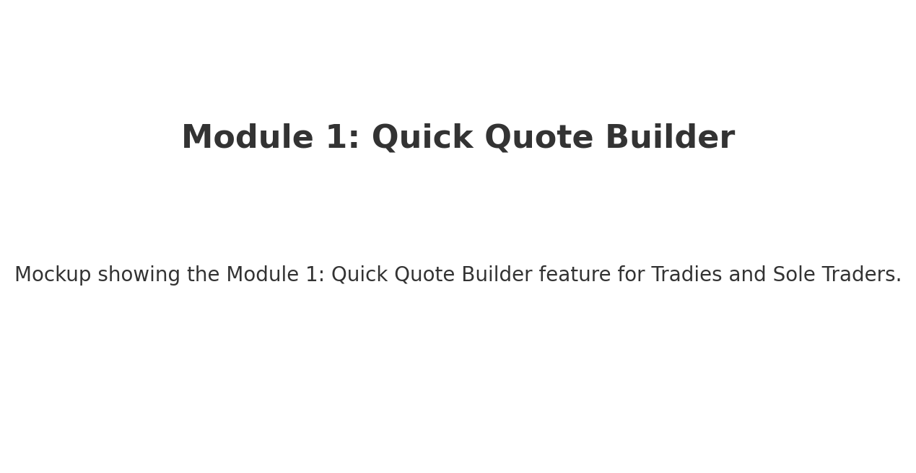
Visual Explanation for 'Module 1: Quick Quote Builder':
This mockup shows a clean, simple interface for the Module 1: Quick Quote Builder module. It focuses on making the process quick, even when using a small mobile screen, with all the key fields and actions right at your fingertips.

Module 2: Invoicing and Payments
Here’s what 'Module 2: Invoicing and Payments' means for a tradie or sole trader using SalesKik:
- Convert approved quotes into invoices instantly.
- Accept card payments on-site or online.
- Track overdue invoices and send automated reminders.
Once the job’s complete, turn your quote into an invoice instantly. Take payment right there—whether that’s by card, bank transfer, or online payment link—so you don’t have to chase them later. It also keeps track of who’s paid and who hasn’t.
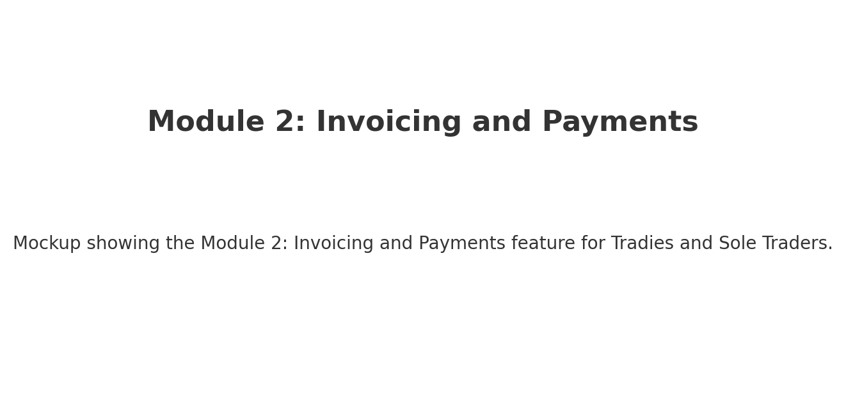
Visual Explanation for 'Module 2: Invoicing and Payments':
This mockup shows a clean, simple interface for the Module 2: Invoicing and Payments module. It focuses on making the process quick, even when using a small mobile screen, with all the key fields and actions right at your fingertips.

Module 3: Job Scheduling
Here’s what 'Module 3: Job Scheduling' means for a tradie or sole trader using SalesKik:
- Drag-and-drop calendar to book jobs, reschedule, and set reminders.
- Color-coded job types for easy visual scanning.
- Sync with Google Calendar or iCal to keep all bookings in one place.
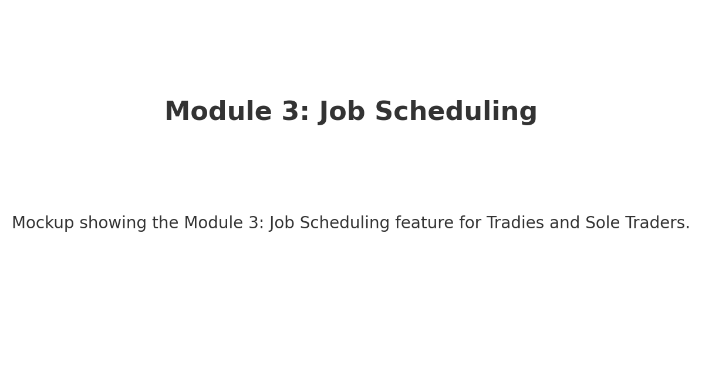
Visual Explanation for 'Module 3: Job Scheduling':
This mockup shows a clean, simple interface for the Module 3: Job Scheduling module. It focuses on making the process quick, even when using a small mobile screen, with all the key fields and actions right at your fingertips.

Module 4: Customer Management
Here’s what 'Module 4: Customer Management' means for a tradie or sole trader using SalesKik:
- Store all customer details, job history, and notes in one profile.
- Tag customers (e.g., 'VIP', 'Overdue Payment', 'Repeat Client').
- Search customers quickly by name, address, or phone number.
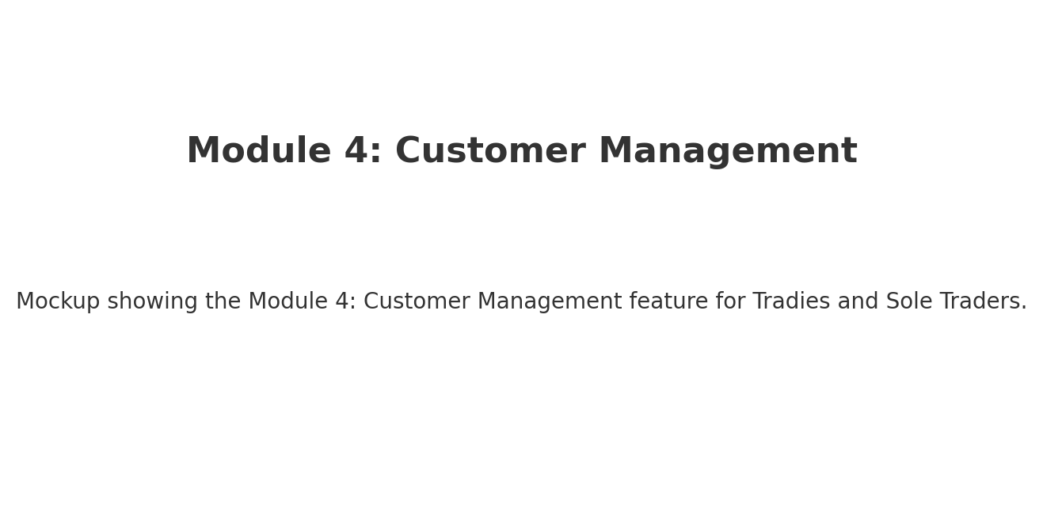
Visual Explanation for 'Module 4: Customer Management':
This mockup shows a clean, simple interface for the Module 4: Customer Management module. It focuses on making the process quick, even when using a small mobile screen, with all the key fields and actions right at your fingertips.

Module 5: Material and Cost Tracking
Here’s what 'Module 5: Material and Cost Tracking' means for a tradie or sole trader using SalesKik:
- Track the materials used per job and auto-add to the invoice.
- Log costs for fuel, subcontractors, or special orders.
- See profit per job in real time.
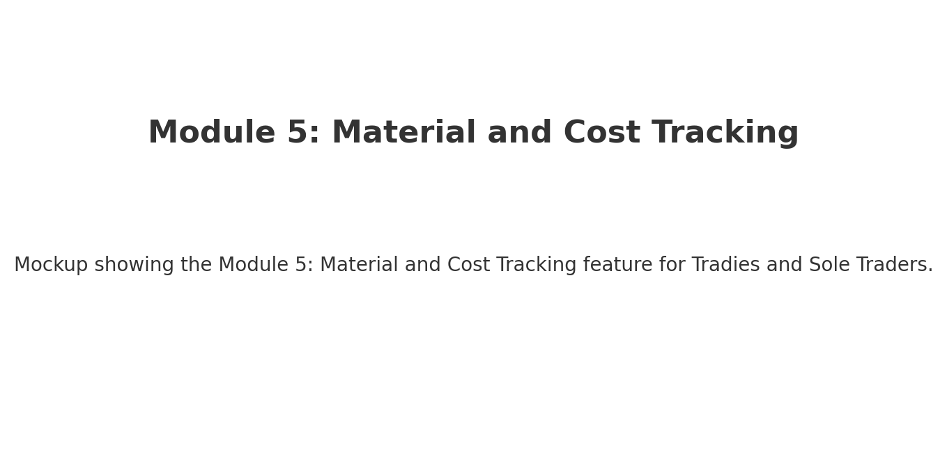
Visual Explanation for 'Module 5: Material and Cost Tracking':
This mockup shows a clean, simple interface for the Module 5: Material and Cost Tracking module. It focuses on making the process quick, even when using a small mobile screen, with all the key fields and actions right at your fingertips.

Module 6: On-the-Go Access
Here’s what 'Module 6: On-the-Go Access' means for a tradie or sole trader using SalesKik:
- Full mobile-friendly interface for quoting, invoicing, and scheduling.
- Offline mode for remote work sites with auto-sync when back online.
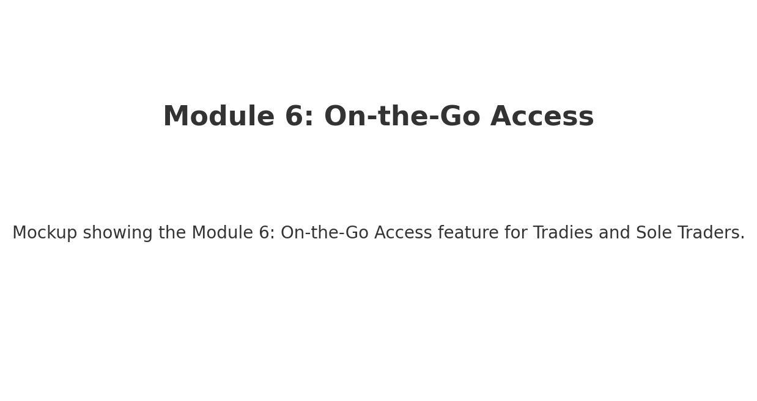
Visual Explanation for 'Module 6: On-the-Go Access':
This mockup shows a clean, simple interface for the Module 6: On-the-Go Access module. It focuses on making the process quick, even when using a small mobile screen, with all the key fields and actions right at your fingertips.

Module 7: Simple Reports
Here’s what 'Module 7: Simple Reports' means for a tradie or sole trader using SalesKik:
- View weekly or monthly summaries of income, expenses, and outstanding payments.
- Filter by job type, customer, or location.
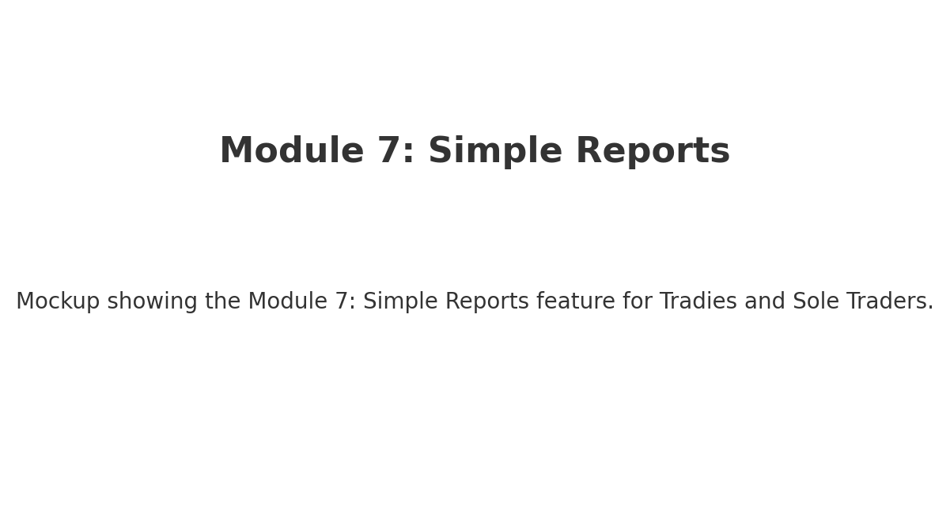
Visual Explanation for 'Module 7: Simple Reports':
This mockup shows a clean, simple interface for the Module 7: Simple Reports module. It focuses on making the process quick, even when using a small mobile screen, with all the key fields and actions right at your fingertips.

